**UCL IXN & GOSH Dashboard for Visualising Infusion Pump Data of Patients.**

**Team members: Daulet Batayev, Henry Ching, Tianang Chen**

**Introduction**

Infusion pumps deliver nutrients and medications into a patients’ body in controlled amounts. So far, clinicians at Great Ormond’s Saint Hospital (GOSH) have been manually collecting that feed information from patients. GOSH has no digital system in place that would monitor the feed data, analyse it and present it in a concise, user-friendly manner. Over the past academic year, we have been closely working with GOSH to develop a smart dashboard that reads the live data from an infusion pump and visualises that information for both clinicians and patients.

**The Challenge**

Manually collecting feed information from patients, takes a lot of clinicians’ precious time, and it is quite a repetitive and dull task. While some patients are being treated at a hospital, there is a large number of those undergoing treatment at home. Since there are a lot of recordings to take during the day, the feed data provided by the patients or their relatives are often inaccurate, therefore it’s unclear whether the patient is receiving the prescribed amount of feed. This results in false positives about the efficiency of the treatment.

With the recent developments of smart digital infusion pumps, there is an opportunity to automate and optimise this process. Having a dashboard that would read the live data from the infusion pump will massively speed up data gathering by avoiding middlemen. Finally, visualising that feed data will help clinicians get insights into the patient’s body and create a much more tailored treatment plan.

**Approach**

To achieve the aforementioned goals, we developed a seamless, user-friendly system for both clinicians and patients, which incorporates a dashboard for visualisation of the live data from the infusion pump. The solution also provides a great feedback system for patients to explain any abnormalities in the feed data. Clinicians make use of the dashboard’s extensive filtering and configuration techniques to analyse the long-term data to come up with better treatment plans for patients.

**Our Solution**

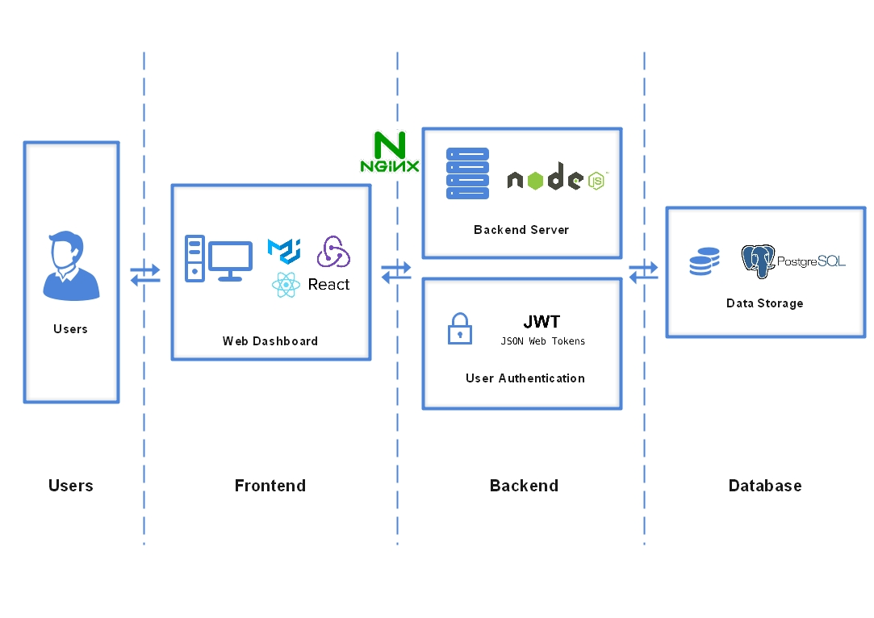

The dashboard is a progressive web application and there are three main pieces for this project: the client frontend, the server backend, and the database. The frontend was developed in React and used Redux for state management. It consists of the following main components: authentication system, patient dashboard, clinician dashboard, patient information and treatment history. We use chart.js to visualise the data as well as for giving feedback to certain abnormal points in the graph. The user interface is responsive and is compatible with any operating system and device. The UI is intuitive and our users enjoyed the simplistic design.

The backend of the application was developed with Node.js and Express framework and is responsible for authentication, authorisation, fetching data from the infusion pump, changing treatment plans, accessing treatment history, and many more. Security and reliability were our number one priority, therefore, the system uses JWT tokens for authorisation. The system’s database is the highly available PostgreSQL and is structured as follows:

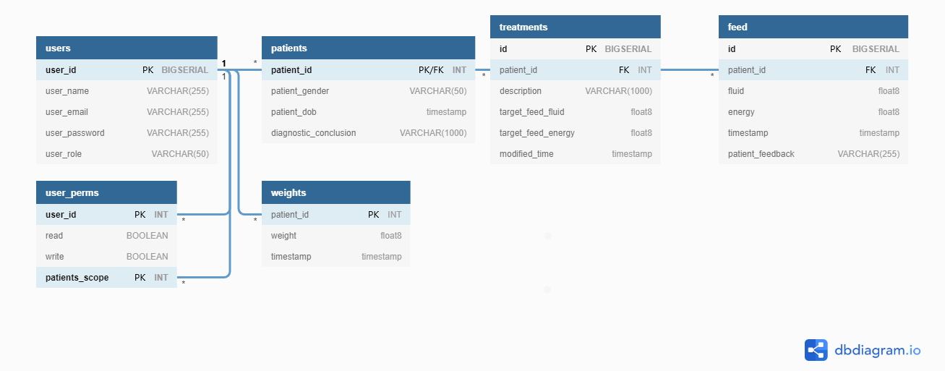

**Testing and evaluation**

The testing phase consisted of both automated and manual tests. The automated tests included backend unit and integration tests, frontend snapshot tests, and end-to-end tests. We used Jest and Cypress for this phase, and achieved a code coverage close to 100%, and we’re confident in the quality of the project after all tests were passing.

The manual tests were comprised of responsive design tests, user acceptance tests, compatibility tests. The project has proven to be responsive across different screen resolutions, operating systems, and devices.

**What Does This Mean for GOSH?**

This project has a crucial value for GOSH. It automates the tedious task of collecting feed information from the patients, and, more importantly, record more accurate data, since it comes straight from the pump recordings. This and the dashboard’s long-term filtering functionality have a seminal value when evaluating the efficiency of past treatments of the patients and for creating new tailored treatment plans.

Patients’ treatment will directly benefit from this application. The clinicians can seamlessly monitor all the desired data, provide feedback, view patient information, treatment history, and change treatment plan all from a single dashboard. Cutting off the middle-men when recording the infusion pump data will save a lot of clinicians’ time so that they can dedicate it to treating more patients.

**Next Steps**

There is a lot of room for improvement for the dashboard. The full automation with smart infusion pumps is yet to be developed. Another important milestone will be integrating FHIR standards into the application, which we were not able to complete due to time constraints. Finally, adding machine learning algorithms for inferring common patterns from the feed data can potentially give invaluable insights into the treatment and can find patterns that clinicians otherwise would not be able to come across.